MINUTES OF MEETING OF THE CONGREGATION
10.45 am Sunday 04 December 2022

In attendance: 37 Chairperson: Bruce Ind
Apologies: 13 Secretary: Craig Mackenzie

- WELCOME and APOLOGIES

In opening the meeting and welcoming those present, Bruce
- acknowledged that we meet on the land of the Kaurna people
- Outlined the method for indicating to speak to the meeting (blue – cool response, orange – warm response, yellow – raise a question, blue and yellow card together – sufficient time for discussion – move on)
- Members joining the meeting online – are able to ask questions and make comment via SMS text message
- members attendance to be recorded by the secretary and invited members to voice apologies they may know of to the secretary after the meeting
- drew attention to the papers distributed by email,
  - Agenda,
  - Minutes of meeting of the congregation held 09 October 2022

- CONFIRMATION OF AGENDA

The meeting accepted (consensus), the agenda for the meeting

- Welcome, Kaurna Acknowledgement
- Apologies
- Confirmation of Agenda
- Confirmation of Minutes – 09 October 2022 (taken as read)
- Resourcing and Enabling Mission
  - Presentation of Budget for 2023
- Spring into Action
  - Brief verbal report of progress since 9 October 22
- Report from Wider church Involvement
- Any Other Business
- Meeting Close

- CONFIRMATION OF MINUTES

Chairperson noted that while the minutes were brief, a number of members had suggested that they include that the meeting RESOLVED to ACCEPT the following Core Ministry Areas for consideration as Morialta UC aspires to future action; recognising that ongoing work will be required in assessing how each area might be implemented:
- WORSHIP and SPIRITUALITY
Emphasis and practices which nurture a spiritual attitude and approach.
- ON-LINE MINISTRY
Continuing current streaming of Worship and expanding on-line ministry formats
- SENIORS
Worship and activities
- CHILDREN & YOUNG ADULTS
Worship and activities
- MULTI-FAITH
Initiatives and connections
- ACTIONS FOR JUSTICE
Refugees, Recent Arrivals, LGBTIQA, and other groups in need

The proposed amendment to minutes was available to the meeting on power point for consideration.

The meeting accepted (consensus), the minutes of the meeting held 09 October 2022 and amendment be recorded in the minutes of the 9 October meeting.

- RESOURCING AND ENABLING MISSION

4.1 Presentation of Budget for 2023

There has been several years of deficit budgets, and considerable effort has been spent in preparing 2023 budget, with this in mind.

There will be no capital expenditure in 2023, and only essential repairs and maintenance expenditure in 2023 has been budgeted for.

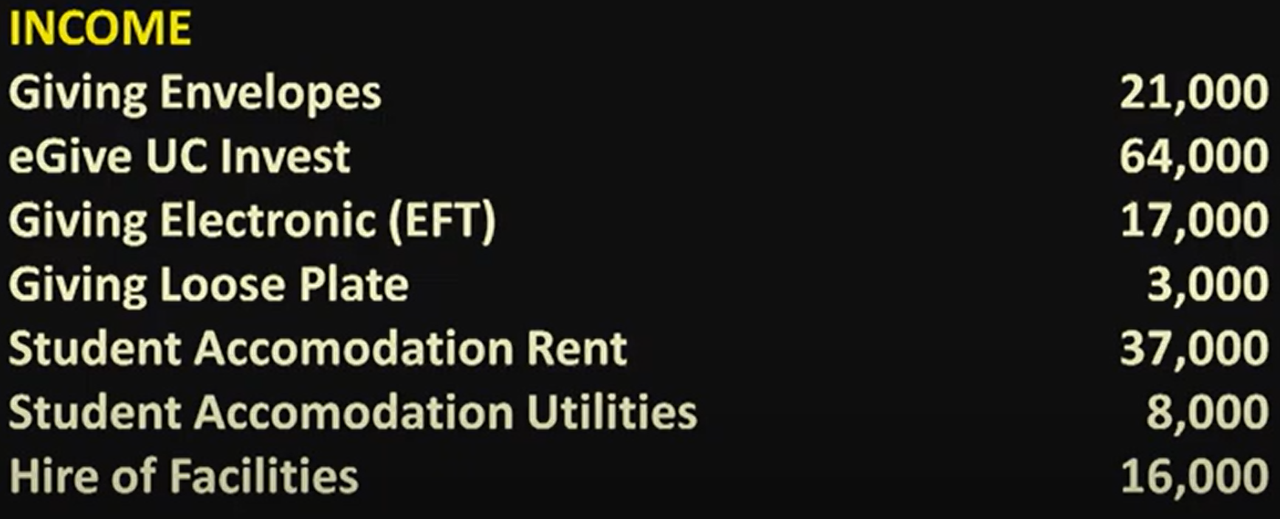
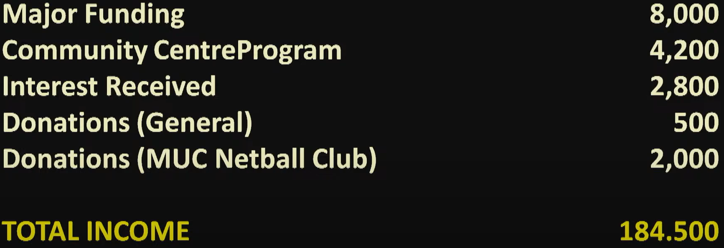
Steve Begg: Q: Asked if these were best estimates or conservative.
A: Conservative estimates. It is also recognised that financial pressures have also factored in the responses to consider giving

Ruth Pitt: Q: Why is Morialta Netball Club providing a donation rather than a court rental hire
A: This year all hirers of Morialta’s facilities will be reviewed.
Newton UC had a strong Netball club when they amalgamated with Magill UC in the formation of Morilata UC. Morialta has sponsored the Netball club for the last 30-40 years.

Colin Cargill C: Plan to increase concerts and other programs now that COVID restrictions over the last few years have eased. The fund raising and community building team would like to hear of possible fund-raising activities. It would also be appreciated where possible if they were able to be supported by people from Morialta.

Marion Beard Q: Does the Netball club donation include the funds raised from the Mother’s Day stall.
A: These funds go to mission projects

Ruth Pitt: C: Our MP came to the Mighty Magill Market, perhaps we could encourage the use of our hall for a future polling booth.
A: Response at the time of the Federal election, it was stated that, our facility was not needed. We will continue to pursue this option.

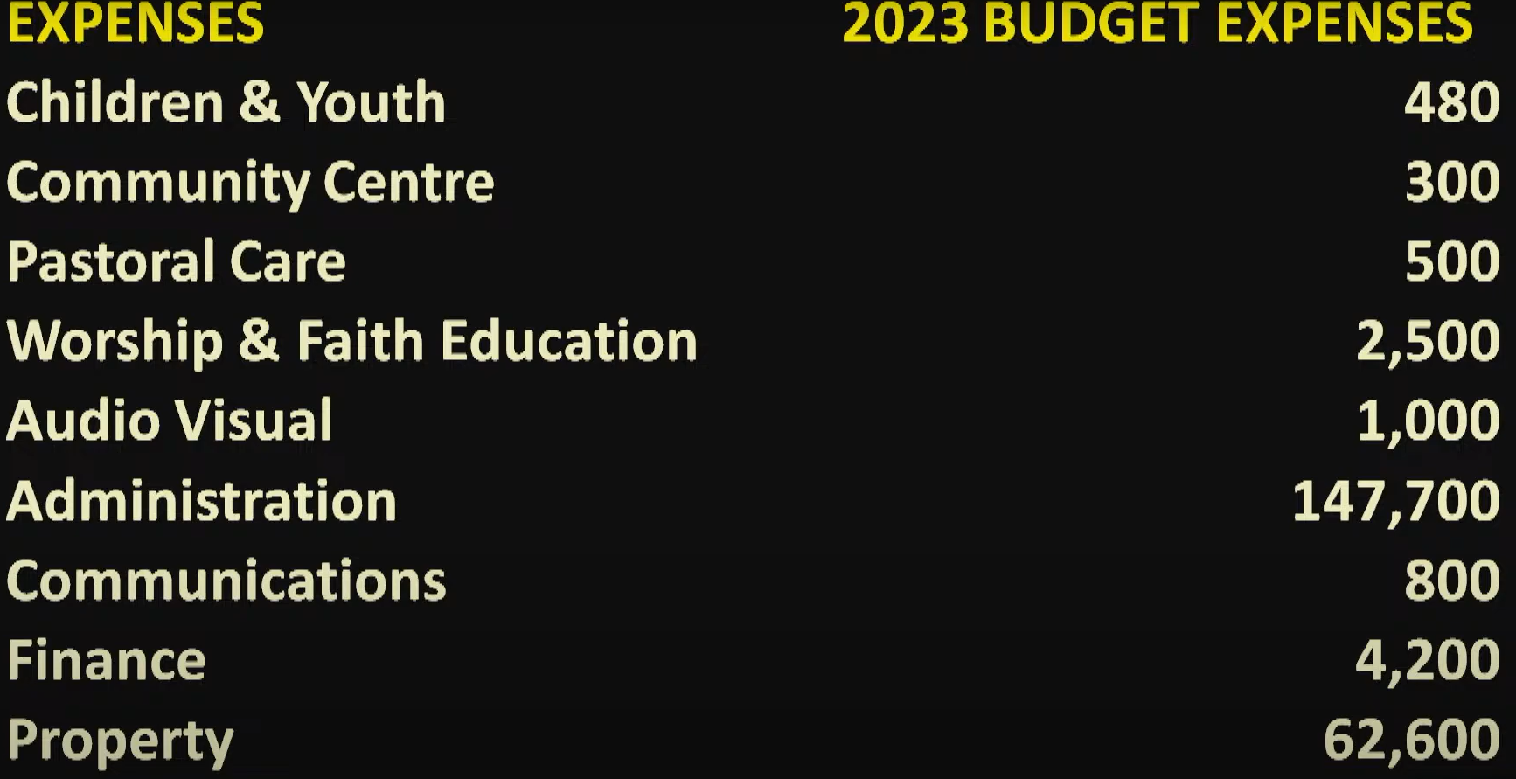

Ruth Pitt: Q: Why do Synod pay for /contribute to property insurance.
A: Response It is the responsibility for each congregation to look after their property

Christine Garner: C: The properties are kept in trust for all people not just the property trust

After careful consideration by Team Leaders, Finance Team and Church Council the budget as presented is proposed

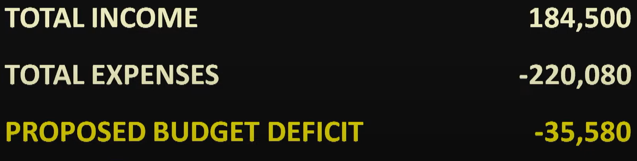

Steve Begg: C: Pleased to see the discipline applied in the budget proposal:
It is still a deficit budget: there are three responses to this:
- Increase income
- Reduce expenditure to balance with income
- Continued running a deficit with a proposed closure

Marion Beard: Q: How much is the proposed deficient less than last year, and how does stopping Lunch on Chapel impact on this.
A: The budgeted deficit last year was $51,000; the actual deficit will be about $22,000 after careful management of expenditure.

Christine Garner: Q: What is the balance of funds if this deficit budget is accepted.
A: There will be a reasonable amount of funds, enough for about 5 years of similar deficit budgets.

The budget proposal was ACCEPTED with CONSENSUS

- SPRING INTO ACTION

5.1 Brief Verbal Report of Progress since 9th October

A couple of meetings of people who have responded to Spring into Action questionnaire and options

4 Key areas identified for immediate actions:

Conversations with Netball Club:
- How do they manage raising of funds, advertising, etc:
- Exploration of hiring arrangement of netball courts and facilities rather than donation
- The netball club has several hundred members - How can we connect more with them and they with us

Advertising and Promotion
- Facebook, Website
- Letter box dropping immediate area (Norwood Parade to Magill University Campus)/ community organisations Probus, knitting club’s etc.
- Advertising for services and events throughout the year e.g., Christmas/ Easter / fundraising community events

Continuing the relationship, with the Dawoodi Boras
- How can we support them
- How can they support us
- Entering into a memorandum of understanding on the use of our facilities
- Exploring interfaith connections with the group that meet at Morialta

Connecting with the city of Burnside and City Campbelltown Councils
- This who we are what we can offer
- What do they need
- Partnerships on the use of our property for community use.
- What are some of the long-term relationships we can develop – development of our property for mutual benefit of the community

Ruth Pitt Q: Can we provide link addresses ahead of time
A: Needs to be explored with A/V – but the most effective way would be to direct to the website.
A: QR codes may be a possibility

- WIDER CHURCH – REPORTS

Bob indicated some of his and other members involvement in the wider church activities:

- Bob is part of Wimala Presbytery Committee
- Bob involved with Ministerial Placements Committee – across the Synod
- Members (Bruce Ind) are on Synod Standing Committees
- Bev Treadrea’s, return from Korea – partnerships with the Wimala Presbytery
- Bob is the Chairperson of the Spicer Cottages Trust
- Milpara Home – thanksgiving luncheon for visitors to Milpara at Rohnda Amber‘s home
- Doug is involved with Milpara and Memorial Hospital visiting
- Bob conducts a service at Clayton Church Homes – Magill once /month
- Other Members of Congregation are involved in Synod committees
- Colin Cargill – social justice and environmental action groups
- Inter church event – Beyond the Garden Gate - environmental action seminars

We have great visual/lighting/audio/comfortable chairs & meeting places/tea/coffee facilities to host these sort of social action/ justice groups/ concerts/activities/meetings/seminars

Ruth Pitt Q: School Chaplaincy Support?
A: Magill Inter Church Council has folded, and the local churches in our area are no longer actively involved in supporting school chaplains in our area. There are still school chaplains, these are supported by the Schools Ministry Group and government funding. The funds Morialta had invested for support of school chaplains have been transferred to the Schools Ministry Group. Morialta through the efforts of Carole Lyons and Colin Cargill, has been a long supporter of School Chaplains.

Q: Ecumenical World Day of Prayer?
A: This is still held. This year it was organised by the Lutheran Church

Q: Support for Mission Projects – seems to have dwindled since COVID:
A: The amount raised for Mission Projects was $2,200 church Council approved funds be raised to $3,000 this year we have supported the following projects:
- Congress at Oodnadatta - $1,500
- Uniting World Project to support Educating girls in North India - $1,500

There have also been disaster appeals – Flood, Fires, Ukraine, Lenten & Advent appeals, local mission – speaker from Payneham Road UC.

Morialta has been generous to missions and appeals – and Morialta’s contribution will be quantified.

- MEETING CLOSE

Bruce Ind thanked everyone for their participation, careful consideration of proposals, and contribution to the congregation and the wider Church.

Bob closed the meeting in prayer.

God, we give you thanks,
that you have called us individually and as a community to be the church in this community in this place and beyond,
Inspire us as we go, challenge us on the way, and nurture us with your Word and sacrament,
May we go today in the knowledge that you are the great Advent God,
that is with us Emanuel, incarnate, present.
As we leave, we pray for safe travel, and for the days we have ahead of us.
May the Grace of our Lord Jesus Christ, the love that you give to us, and the fellowship of the Spirit be with us and spur us on.

Amen.

AGENDA

ATTENDANCE AND APOLOGIES

REPORTS

Amended minutes of the meeting held 09 October 2022

Original Draft minutes of the meeting held 09 October 2022

