Main & Sub Woofer Speakers Diagram
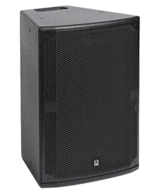
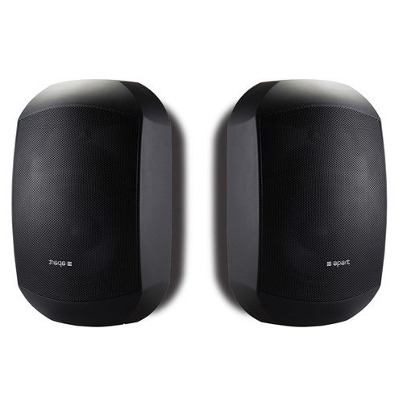
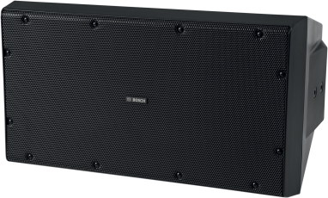
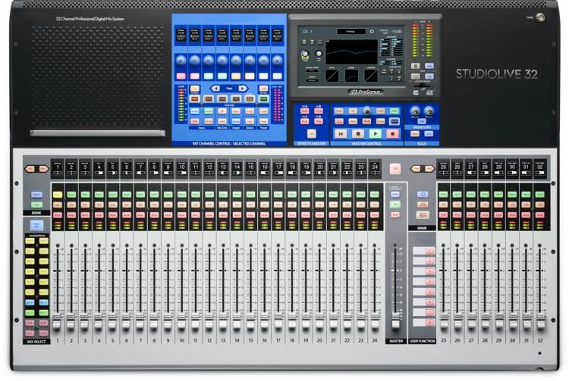
On the floor at the front
Room

In the rack in the Control Room

Main Speakers
Centre Cluster

Equaliser - Main R
dbx Professional Products
20 - 80 Hz @ -15 dB
100 Hz & above @ 0 dB
Range: +/- 15 dB
Input Gain: 0 dB
Type III NR: Off
EQ. Bypass: Off
PeakPlus Threshold: Off

Power Amplifier
TCX-15 Speaker
Equaliser - Main L
dbx Professional Products
20 - 63 Hz @ -15 dB
80 Hz @ -10 dB
100 Hz @ -5 dB
125 Hz & above @ 0 dB
Range: +/- 15 dB
Input Gain: 0 dB
Type III NR: Off
EQ. Bypass: Off
PeakPlus Threshold: Off

In the rack in the Control Room

Power Amplifier
Small Loudspeakers
AV Desk

StudioLive Series 3
Audio Mixer
Crossover
dbx Professional Products
CHANNEL ONE
Input: 0 dB
Low cut: Off
Low/Low-Mid Xover Freq: ~100 Hz
Low Mid/High-Mid Xover Freq: *
Low Output: -20 dB
∅ INV: Off
Low-Mid Output: -∞ dB *
(*: Not used)
Power Amplifier
Behind the reredos
Room

Mix 1

Main
Output

Right

Left

